Crossed Star Shapes
# Source: AI Source: Provided by: [Data Path: Persons Table -> ID Column: 1, Name_En Column: Motasem Essam] -> From: [ChatGPT] on [7/25/2026]
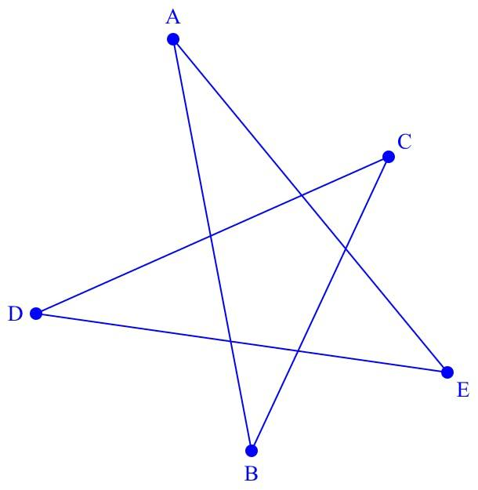
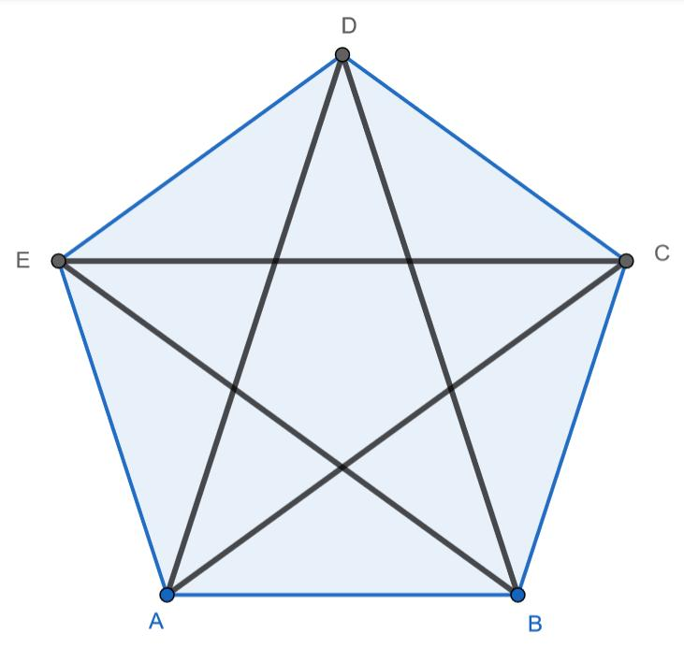
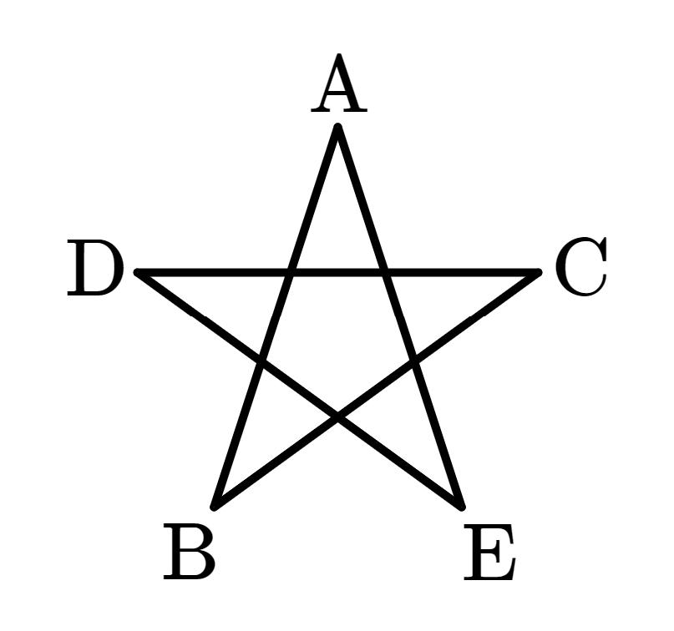
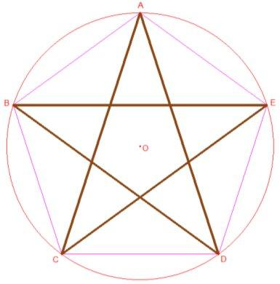
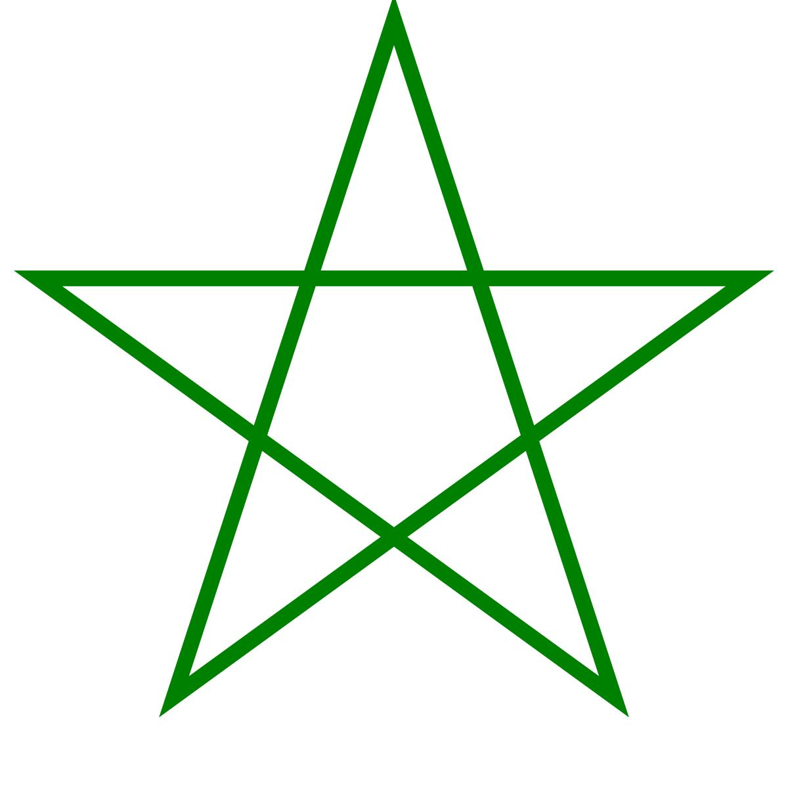

Definition
# Source: AI Source: Provided by: [Data Path: Persons Table -> ID Column: 1, Name_En Column: Motasem Essam] -> From: [ChatGPT] on [7/25/2026]
A Crossed Star Shape is a star-shaped geometric figure whose boundary self-intersects, meaning that two or more non-adjacent edges cross at points other than their endpoints.
Crossed star shapes are therefore a type of self-intersecting shape and, when their boundary is made entirely of straight line segments, they are examples of self-intersecting polygons.
$$\boxed{\text{Crossed Star Shape}=\text{Star-Shaped Self-Intersecting Figure}}$$
A common mathematical example is the pentagram.

Fundamental Characteristics
# Source: AI Source: Provided by: [Data Path: Persons Table -> ID Column: 1, Name_En Column: Motasem Essam] -> From: [ChatGPT] on [7/25/2026]
A crossed star shape may have:
- Multiple points or "tips"
- Straight or curved boundary segments
- One or more self-intersection points
- An inner region
- Outer points extending from the center
- Rotational and/or reflection symmetry in regular examples
The defining characteristic is:
$$\boxed{\text{The boundary crosses itself}}$$

Crossed Star Polygon
# Source: AI Source: Provided by: [Data Path: Persons Table -> ID Column: 1, Name_En Column: Motasem Essam] -> From: [ChatGPT] on [7/25/2026]
When a crossed star shape is constructed entirely from straight line segments and forms a closed polygonal path, it can be called a Star Polygon.
For example, a five-pointed star formed by connecting the vertices of a regular pentagon in a non-consecutive order is a pentagram.
$$\boxed{\text{Pentagram}=\text{Self-Intersecting Star Polygon}}$$

How a Crossed Star Is Formed
# Source: AI Source: Provided by: [Data Path: Persons Table -> ID Column: 1, Name_En Column: Motasem Essam] -> From: [ChatGPT] on [7/25/2026]
A regular star polygon can be constructed by:
- Starting with the vertices of a regular polygon.
- Choosing a fixed number of vertices to skip when connecting each vertex.
- Connecting the vertices repeatedly.
- Continuing until the path closes.
For a regular $n$-gon, connecting every $k$-th vertex produces a star polygon when:
$$1<k<\frac{n}{2}$$
and:
$$gcd⁡\left(n , k\right)=1$$
ensures that one continuous path visits all $n$vertices before returning to the starting point.
The resulting notation is commonly written as:
$$\boxed{\left\{n/k\right\}}$$
where:
- $n$= number of vertices
- $k$= connection step

Example: Pentagram
# Source: AI Source: Provided by: [Data Path: Persons Table -> ID Column: 1, Name_En Column: Motasem Essam] -> From: [ChatGPT] on [7/25/2026]
A pentagram can be represented as:
$$\boxed{\left\{5/2\right\}}$$
It has:
- 5 vertices
- 5 outer points
- 5 main boundary edges
- 5 self-intersection points
- 5-fold rotational symmetry
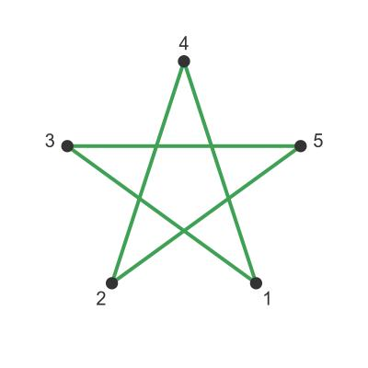
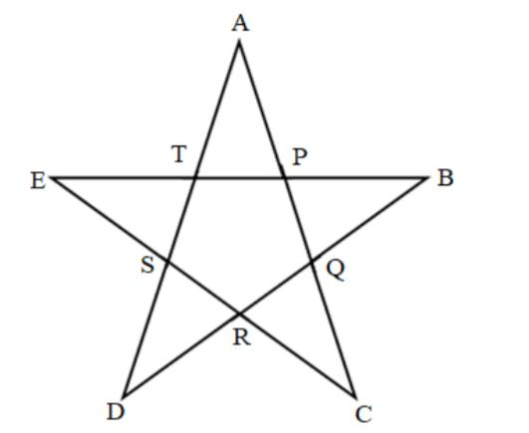
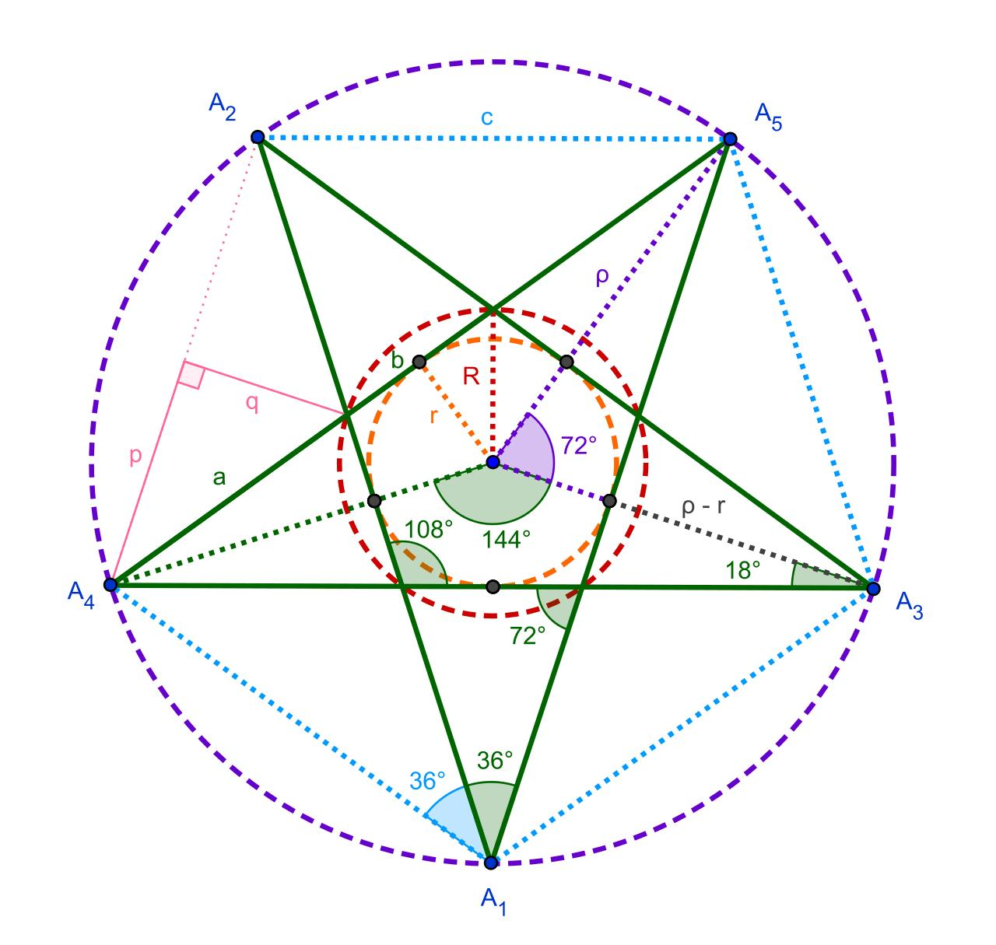
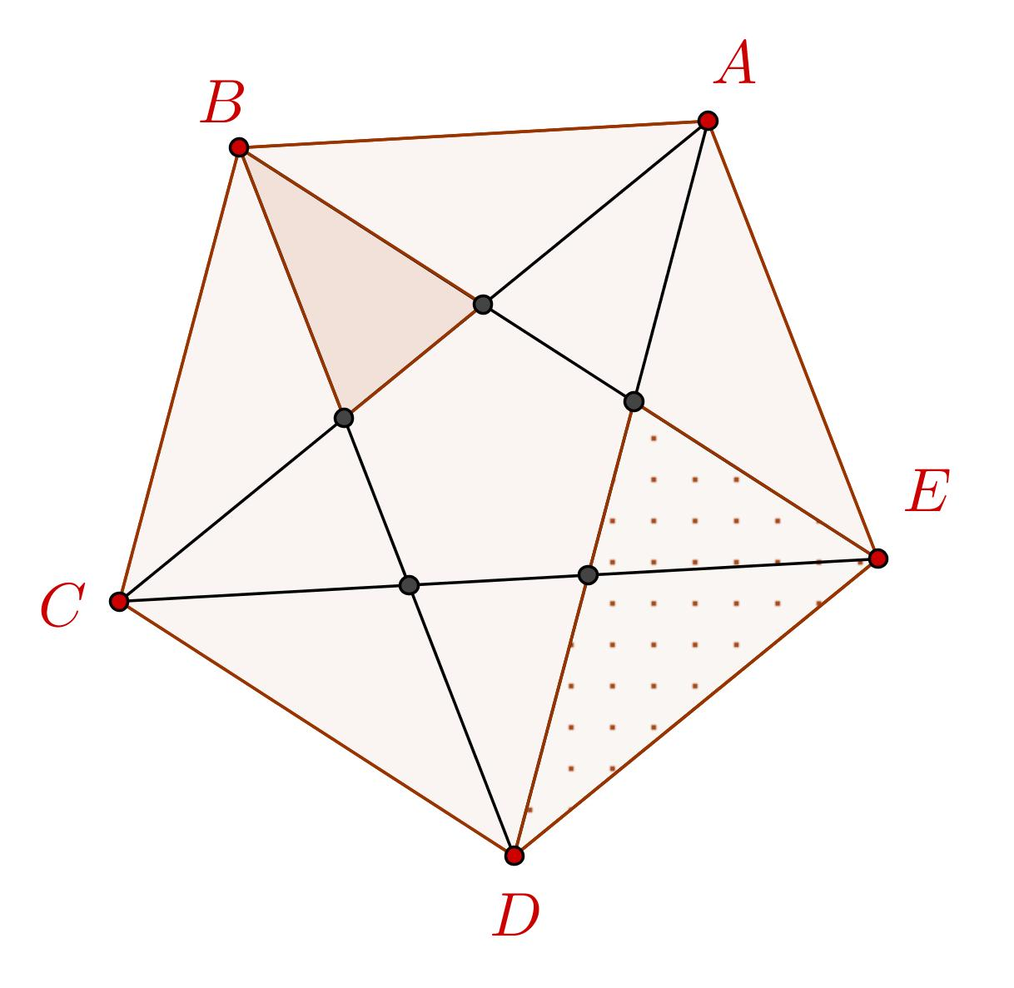

Self-Intersection Points
# Source: AI Source: Provided by: [Data Path: Persons Table -> ID Column: 1, Name_En Column: Motasem Essam] -> From: [ChatGPT] on [7/25/2026]
The edges of a crossed star intersect at points that are not vertices.
If two edges intersect at $O$:
$$\boxed{AB∩CD=O}$$
then $O$is a self-intersection point.
A star can have several such points.
For a regular pentagram, the intersections form a smaller pentagon in the center.

Types of Crossed Star Shapes
Crossed star shapes can be classified according to the number of points.

Five-Pointed Star
# Source: AI Source: Provided by: [Data Path: Persons Table -> ID Column: 1, Name_En Column: Motasem Essam] -> From: [ChatGPT] on [7/25/2026]
$$\boxed{\left\{5/2\right\}}$$
The pentagram is the most familiar example.

Seven-Pointed Star
# Source: AI Source: Provided by: [Data Path: Persons Table -> ID Column: 1, Name_En Column: Motasem Essam] -> From: [ChatGPT] on [7/25/2026]
A seven-pointed star can be constructed from:
$$\left\{7/2\right\}$$
or:
$$\left\{7/3\right\}$$
depending on the connection pattern.

Eight-Pointed Star
# Source: AI Source: Provided by: [Data Path: Persons Table -> ID Column: 1, Name_En Column: Motasem Essam] -> From: [ChatGPT] on [7/25/2026]
Examples include:
$$\left\{8/3\right\}$$
and other star-like constructions.

General Star Polygon
# Source: AI Source: Provided by: [Data Path: Persons Table -> ID Column: 1, Name_En Column: Motasem Essam] -> From: [ChatGPT] on [7/25/2026]
A regular star polygon can be represented by:
$$\boxed{\left\{n/k\right\}}$$
subject to the appropriate conditions on $n$and $k$.

Simple Star Shape vs. Crossed Star Shape
# Source: AI Source: Provided by: [Data Path: Persons Table -> ID Column: 1, Name_En Column: Motasem Essam] -> From: [ChatGPT] on [7/25/2026]
Not every visual star shape is necessarily a crossed polygon.
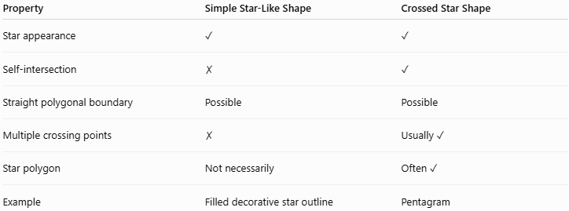
Property | Simple Star-Like Shape | Crossed Star Shape
Star appearance | ✓ | ✓
Self-intersection | ✗ | ✓
Straight polygonal boundary | Possible | Possible
Multiple crossing points | ✗ | Usually ✓
Star polygon | Not necessarily | Often ✓
Example | Filled decorative star outline | Pentagram
The important distinction is self-intersection, not merely the appearance of the shape.

Area
# Source: AI Source: Provided by: [Data Path: Persons Table -> ID Column: 1, Name_En Column: Motasem Essam] -> From: [ChatGPT] on [7/25/2026]
The area of a crossed star shape requires care because its boundary creates multiple regions.
For a specific star, the area can be calculated by:
- Dividing it into triangles.
- Calculating the outer and inner regions separately.
- Using coordinate geometry.
- Using the polygon shoelace formula with an appropriate interpretation.
- Using signed-area methods for self-intersecting polygons.
For example:
$$A=A_{\text{outer regions}}+A_{\text{inner regions}}$$
depending on which region the problem defines as the intended area.
Therefore:
$$\boxed{\text{Area depends on the specified region or area convention}}$$

Perimeter
# Source: AI Source: Provided by: [Data Path: Persons Table -> ID Column: 1, Name_En Column: Motasem Essam] -> From: [ChatGPT] on [7/25/2026]
The perimeter is the total length of all boundary segments.
For a regular star polygon with $n$equal edges of length $s$:
$$\boxed{P=ns}$$
For a pentagram with five equal star edges:
$$\boxed{P=5s}$$

Symmetry
# Source: AI Source: Provided by: [Data Path: Persons Table -> ID Column: 1, Name_En Column: Motasem Essam] -> From: [ChatGPT] on [7/25/2026]
Regular crossed star polygons can have strong symmetry.
A regular $\left\{n/k\right\}$star polygon has rotational symmetry associated with $n$.
For a regular pentagram:
$$\boxed{\text{Rotational symmetry order}=5}$$
Its smallest non-zero rotational symmetry angle is:
$$\boxed{\frac{{360}^{∘}}{5}={72}^{∘}}$$
A regular pentagram also has 5 lines of reflection symmetry.

Relationship with Crossed Polygon
# Source: AI Source: Provided by: [Data Path: Persons Table -> ID Column: 1, Name_En Column: Motasem Essam] -> From: [ChatGPT] on [7/25/2026]
A crossed star polygon is a particular type of crossed polygon:
$$\boxed{\text{Crossed Star Polygon}⊂\text{Crossed Polygon}}$$
The broader hierarchy can therefore be organized as:
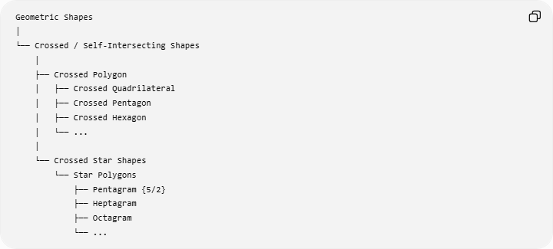
Geometric Shapes
│
└── Crossed / Self-Intersecting Shapes
│
├── Crossed Polygon
│ ├── Crossed Quadrilateral
│ ├── Crossed Pentagon
│ ├── Crossed Hexagon
│ └── ...
│
└── Crossed Star Shapes
└── Star Polygons
├── Pentagram {5/2}
├── Heptagram
├── Octagram
└── ...

Relationship with Simple Shapes
# Source: AI Source: Provided by: [Data Path: Persons Table -> ID Column: 1, Name_En Column: Motasem Essam] -> From: [ChatGPT] on [7/25/2026]
The fundamental classification is:
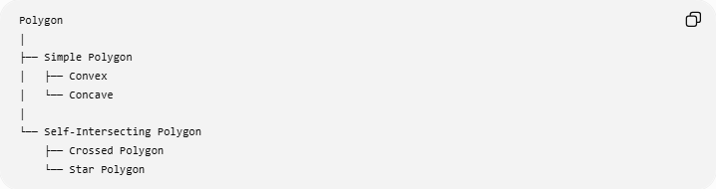
Polygon
│
├── Simple Polygon
│ ├── Convex
│ └── Concave
│
└── Self-Intersecting Polygon
├── Crossed Polygon
└── Star Polygon
Thus:
$$\boxed{\text{Star Polygon}→\text{Self-Intersecting Polygon}}$$
for the regular crossed star-polygon construction.

Example
# Source: AI Source: Provided by: [Data Path: Persons Table -> ID Column: 1, Name_En Column: Motasem Essam] -> From: [ChatGPT] on [7/25/2026]
Consider a regular pentagram $\left\{5/2\right\}$.
It has:
$$n=5$$
vertices and connects every second vertex.
The rotational symmetry angle is:
$$θ=\frac{{360}^{∘}}{5} \\ \boxed{θ={72}^{∘}}$$
The figure contains multiple self-intersection points, so it is a crossed star polygon.

Real-World Applications
# Source: AI Source: Provided by: [Data Path: Persons Table -> ID Column: 1, Name_En Column: Motasem Essam] -> From: [ChatGPT] on [7/25/2026]
Crossed star shapes appear in:
- Decorative patterns
- Logos
- Symbols
- Flags
- Architectural ornamentation
- Art and graphic design
- Computer graphics
- CAD
- Mathematical illustrations
- Tessellations and geometric patterns

Advantages
# Source: AI Source: Provided by: [Data Path: Persons Table -> ID Column: 1, Name_En Column: Motasem Essam] -> From: [ChatGPT] on [7/25/2026]
- Provides visually symmetric geometric structures.
- Useful for studying self-intersection.
- Useful for exploring rotational and reflection symmetry.
- Important in computational geometry and computer graphics.
- Provides examples of complex polygons.

Limitations
# Source: AI Source: Provided by: [Data Path: Persons Table -> ID Column: 1, Name_En Column: Motasem Essam] -> From: [ChatGPT] on [7/25/2026]
- Area calculations are more complicated than for simple polygons.
- The term "star shape" can describe several different mathematical constructions.
- A visual star is not automatically a star polygon.
- Self-intersections make ordinary polygon formulas require careful interpretation.

Comparison
# Source: AI Source: Provided by: [Data Path: Persons Table -> ID Column: 1, Name_En Column: Motasem Essam] -> From: [ChatGPT] on [7/25/2026]
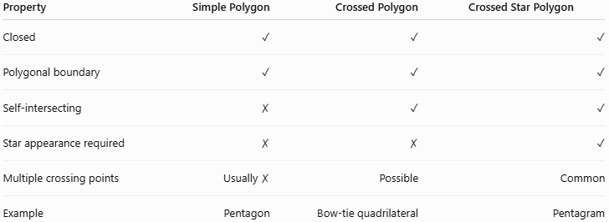
Property | Simple Polygon | Crossed Polygon | Crossed Star Polygon
Closed | ✓ | ✓ | ✓
Polygonal boundary | ✓ | ✓ | ✓
Self-intersecting | ✗ | ✓ | ✓
Star appearance required | ✗ | ✗ | ✓
Multiple crossing points | Usually ✗ | Possible | Common
Example | Pentagon | Bow-tie quadrilateral | Pentagram

Key Points
# Source: AI Source: Provided by: [Data Path: Persons Table -> ID Column: 1, Name_En Column: Motasem Essam] -> From: [ChatGPT] on [7/25/2026]
- Crossed Star Shapes have self-intersecting boundaries.
- A crossed star made entirely of line segments can be a star polygon.
- The pentagram $\left\{5/2\right\}$is the classic example.
- Regular star polygons can be represented using Schläfli notation:
$$\boxed{\left\{n/k\right\}}$$
- Crossed star polygons belong to the broader category of self-intersecting polygons.
- Their area requires special consideration because of the multiple regions created by the crossings.
- Regular crossed star polygons can have rotational and reflection symmetry.

Conclusion
# Source: AI Source: Provided by: [Data Path: Persons Table -> ID Column: 1, Name_En Column: Motasem Essam] -> From: [ChatGPT] on [7/25/2026]
A Crossed Star Shape is a star-like figure whose boundary crosses itself. When constructed as a regular polygonal path, it is a Star Polygon, such as the pentagram.
For your knowledge-base hierarchy, I recommend:
$$\boxed{\text{Crossed Shapes}→\text{Crossed Polygons}→\text{Crossed Star Shapes}→\text{Star Polygons}}$$
with the Pentagram $\left\{5/2\right\}$as the primary example.

